- Download a publicly available dataset of your choice (for example, a Flipkart product ratings dataset or Spotify song features) and split it into features (X) and target (y) for a regression problem.
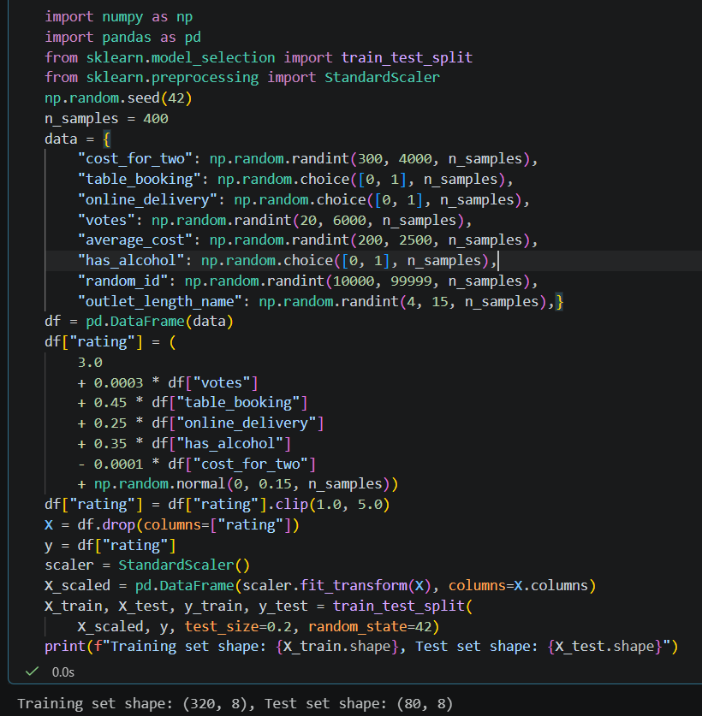

- Fit a Lasso regression model (L1 regularization) using scikit-learn's Lasso class on your dataset, and print out the coefficients for each feature.
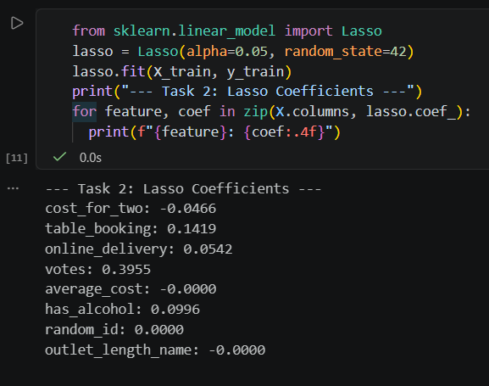

- Fit a Ridge regression model (L2 regularization) using scikit-learn's Ridge class on the same dataset, and compare the coefficients to those from the Lasso model. Look for features where Lasso sets coefficients exactly to zero but Ridge does not.
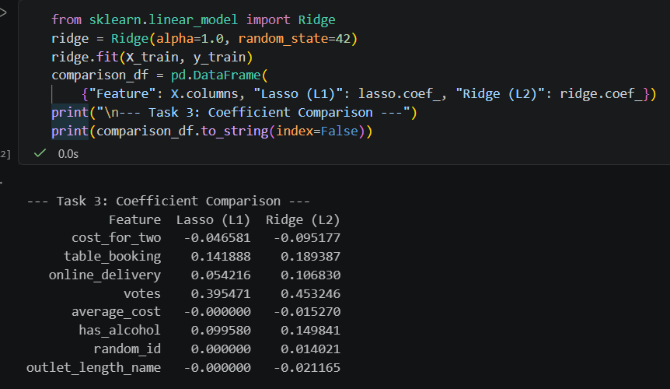

- Fit an ElasticNet regression model using scikit-learn's ElasticNet class, and observe how the coefficients differ from both Lasso and Ridge. Try changing the l1_ratio parameter and see how it affects the results.
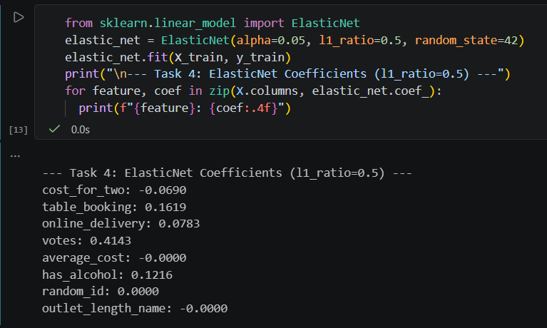

- Suppose you want to build a feature selector for a Zomato-style restaurant rating predictor. Use Lasso regression to select the most important features from your dataset, and list which features are kept (non-zero coefficients) and which are dropped.

